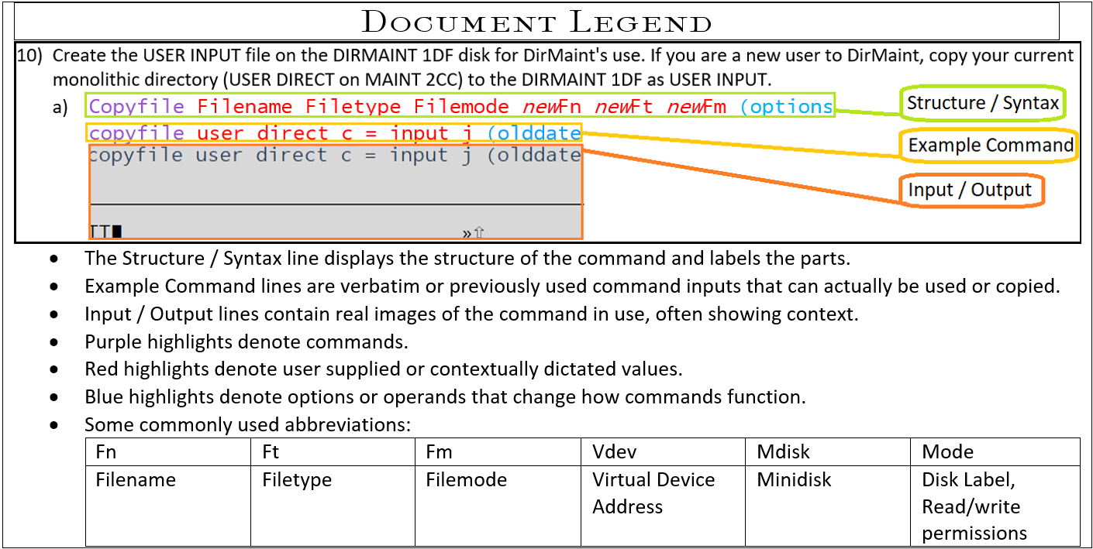

1. Create a new file using Xedit named, “Syn” with a filetype of, “Synonym”. Once the file is open, add four lines and write in the synonym statements.
   1. Create the file.
      1. Xedit filename filetype filemode (options  
         Xedit syn synonym a  
         <image>
   2. Add the necessary lines to fit your commands.
      1. Add #  
         Add 4  
         <image>
2. Write in your synonym command lines and reference names.
   1. Where **Filelist** is the command and ***F*** is the new method of referring to the command.  
      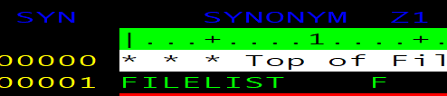
   2. Submit the file command to save your changes.
      1. File  
         <image>
3. Use Xedit to create or edit the user’s profile exec so that it runs the synonym file with the profile.
   1. Open or edit Profile Exec
      1. Xedit filename filetype filemode  
         Xedit profile exec a  
         <image>
   2. Select the line under, “Address Command” and press <F2> or use the add # line command to add a line and write in your new synonym’s filename and filetype, contained in single quotes.
      1. 